

Phone: 904.504.7813 - Fax: 904.372.9569
DMgroup77@aol.com

Boudreaux’s HomeStyle Breaded Oysters

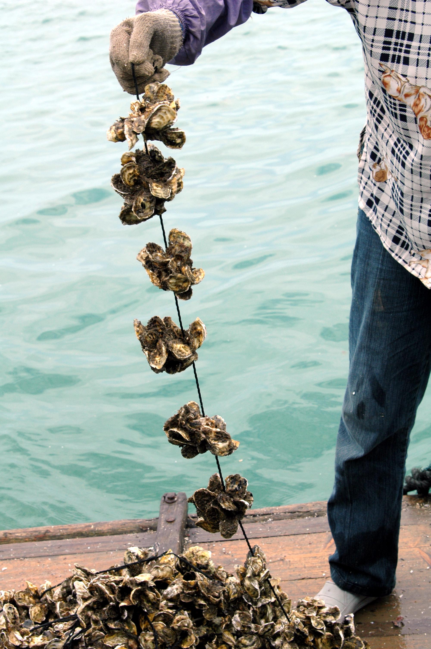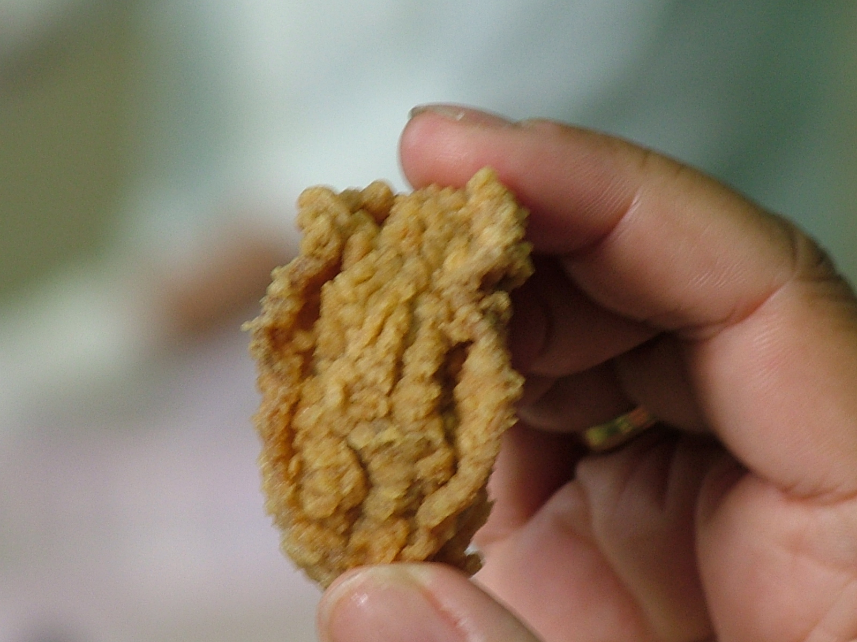

Our Gourmet HomeStyle Breaded Oysters are made with fresh, Gigas Oysters that have been farm-raised using rope mariculture in pristine blue coastal waters along the South China Sea. They are lightly dusted and hand battered with our special blend of seasoned flour (30%), pre-fried, then IQF processed to seal in their mild and naturally salty oyster flavor.

The hand battered process uses a popcorn-type batter that creates a handmade appearance with an outstandingly mild flavor and irregular, gnarly individual shapes that will keep your customers coming back for more.

Make great entrees, appetizers and New Orleans style po-boy sandwiches. 25-35 per pound. Case dimensions: 11” x 8” x 9”. Each case contains 5x2 pound bags. The case cube is 0.50. Net weight is 10 pounds. Tie/High: 18/7

25/35 GTIN 1 0040902 33943 0 Manufacturer Item #: 33943



