

Phone: 904.504.7813 – Fax 904.372.9569
Website: www.gulfmarineproducts.com

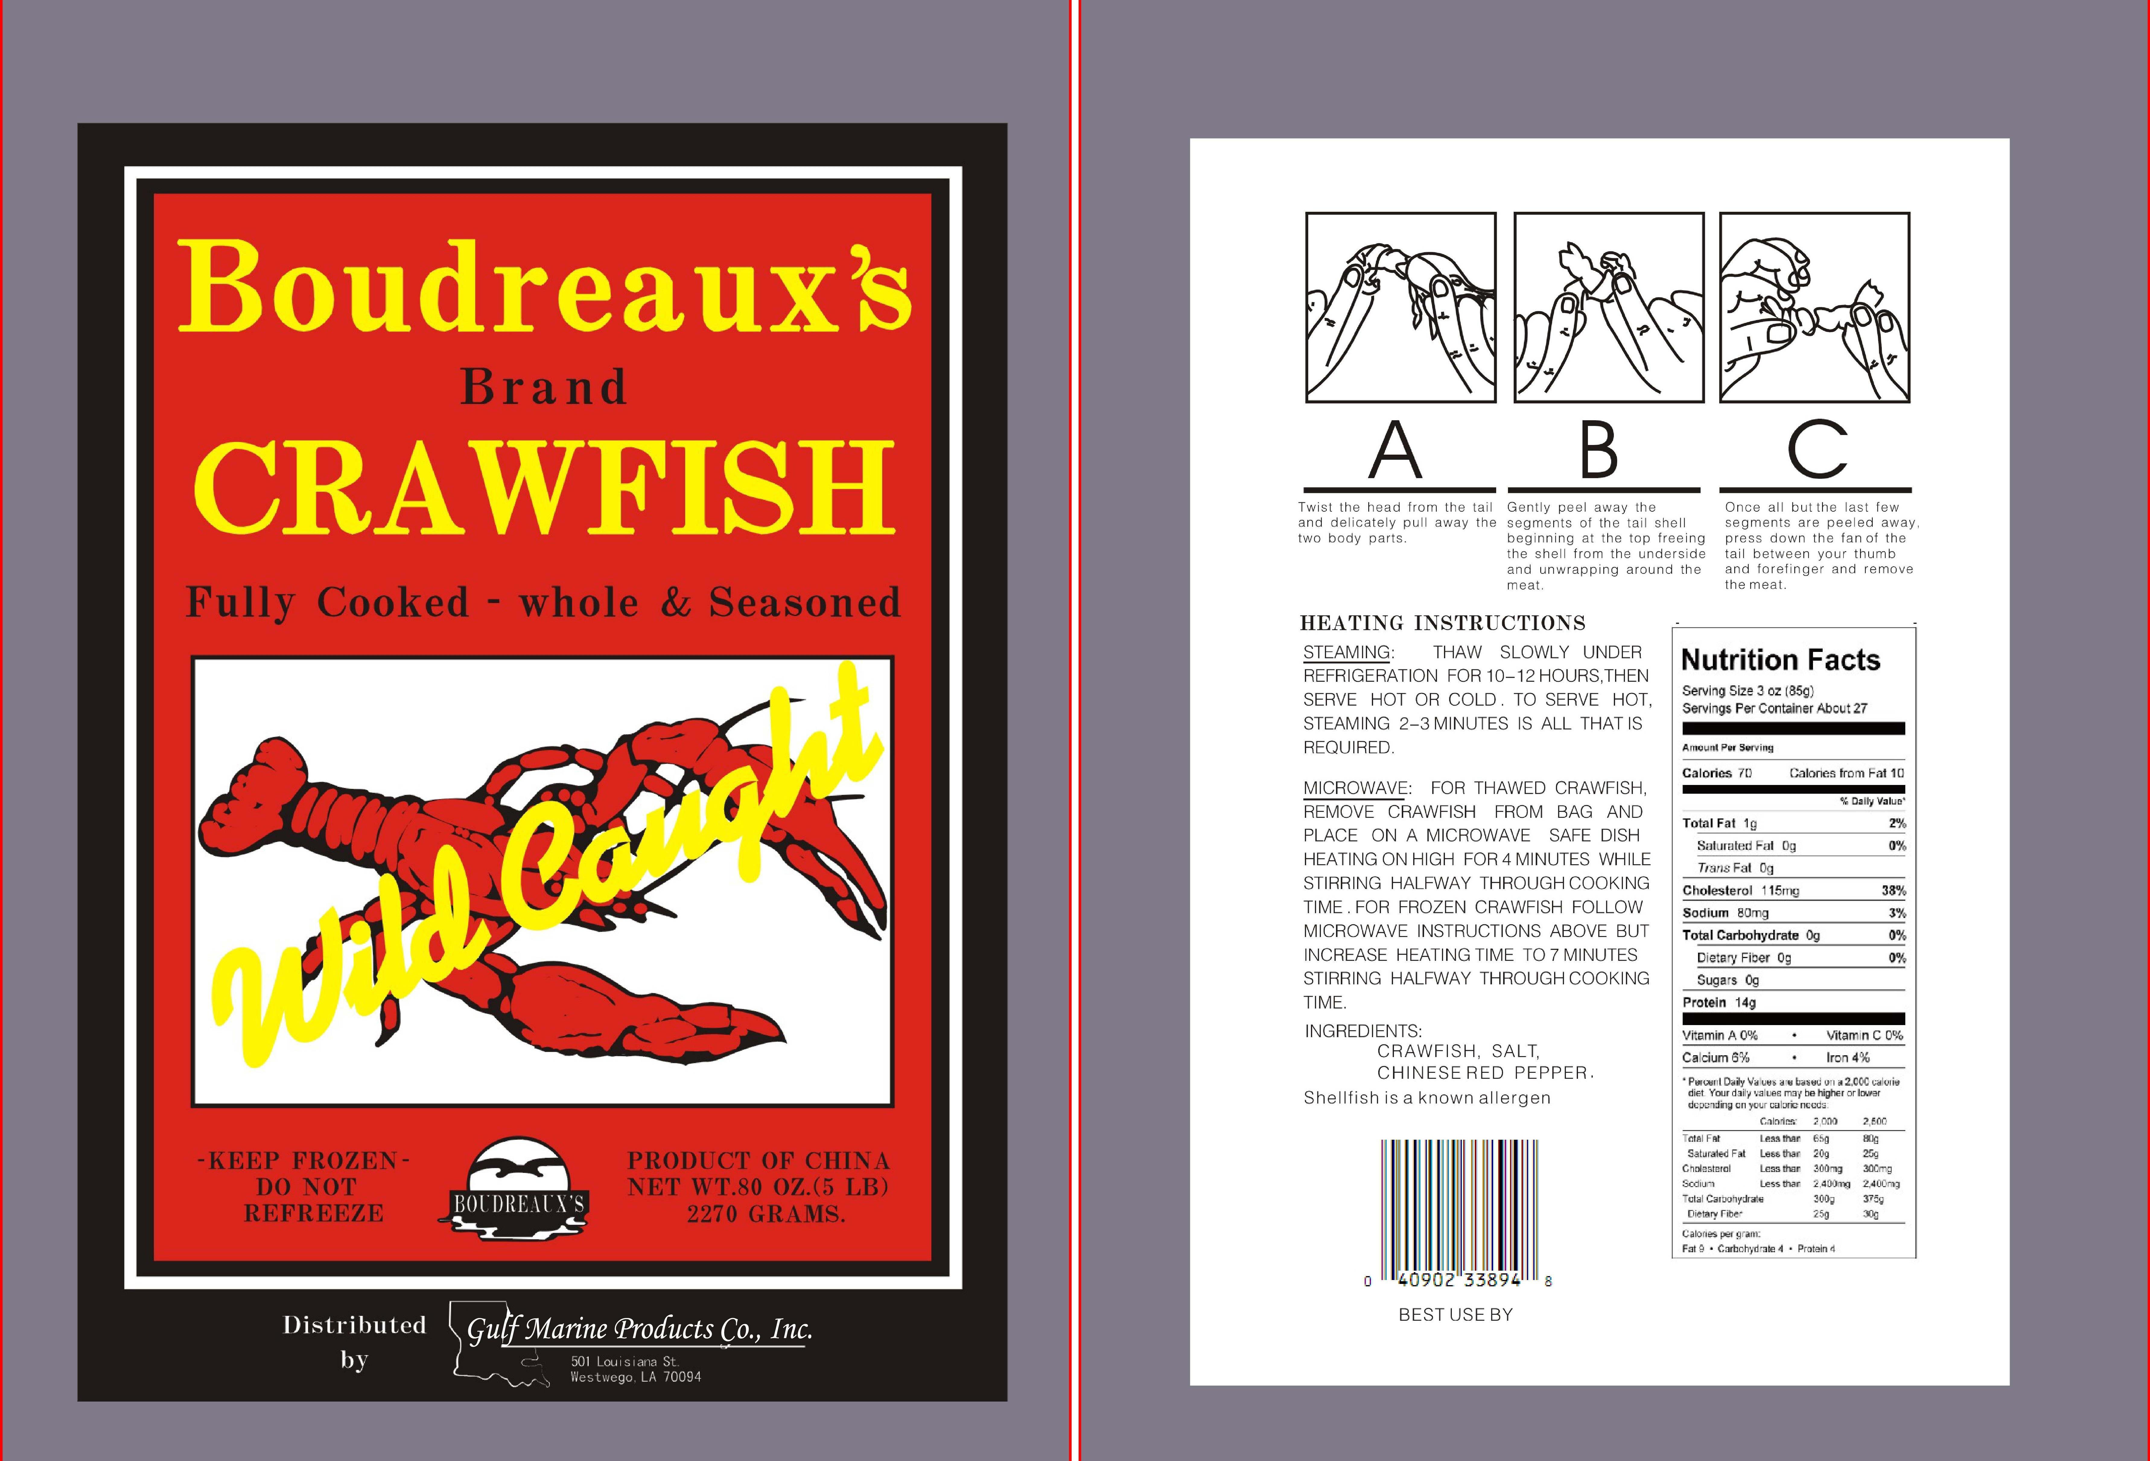

Species: Procambarus Clarkii | Size 16/20
Brand: Boudreaux | Master Case Pack: 2 x 5 lbs
Size: 80 oz | Inner Size Unit Measure: 4 x 16 x 11
Master Case Weight: Net 10 lbs | Master Case Weight: Gross Wt. 12.2 lbs
Case Cube: .47 cubic ft. | Case Size: 16.75” x 11” x 4.375”
Master Case GTIN #: 1 00 40902 33894 5 | UPC #: 0 40902 33894 8
Master Case Tie/Hi: 10 / 11 | Sell By Date: 3 Years from Production Date
Country of Origin: China | Method of Catch: Wild Caught

