501 Louisiana Street, Westwego, LA 70094 USA
Phone: 504.436.2682 - Fax: 504.436.1585
Website: www.gulfmarineproducts.com

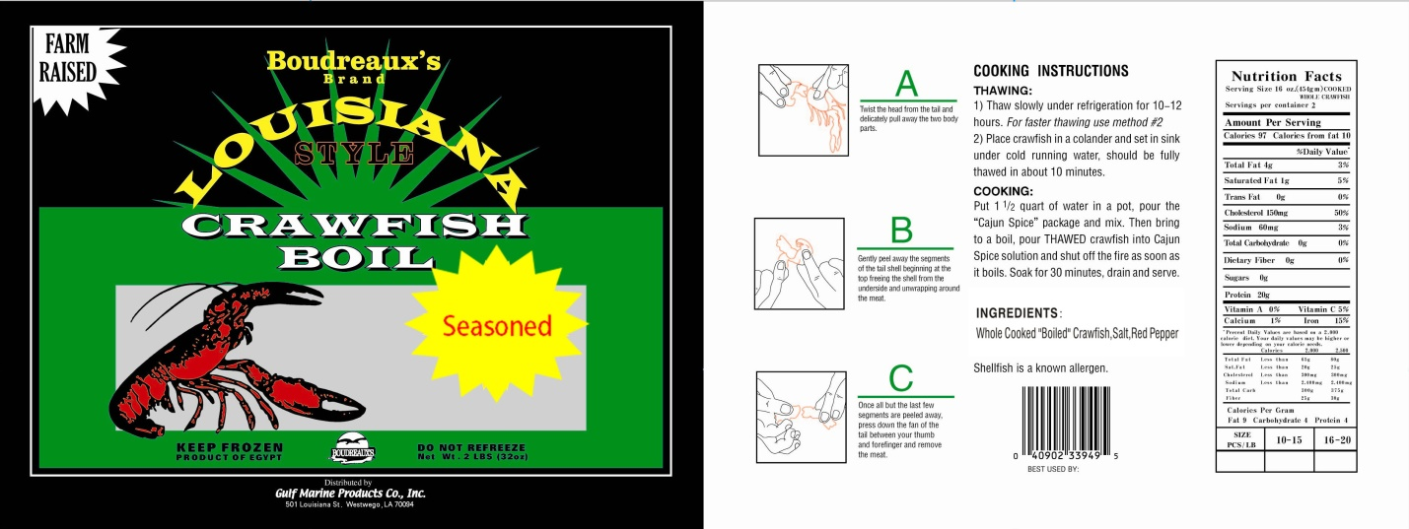

Species: Procambarus Clarkii | Item # 552410818
Brand: Boudreaux | Master Case Pack: 10 x 2 lbs
Size: 32 oz | Size Unit Measure: lbs
Master Case Weight: Net 20 lbs | Master Case Weight: Gross Wt. 22 lbs
Case Cube: 1.0417 cubic ft. | Case Size: 15.5” x 10” x 12”
Master Case GTIN #: 1 00 40902 33949 2 | UPC #: 0 40902 33949 5
Master Case Tie/Hi: 12/5 | Sell By Date: 3 Years from Production Date
Country of Origin: Egypt | Method of Catch: Farm Raised

